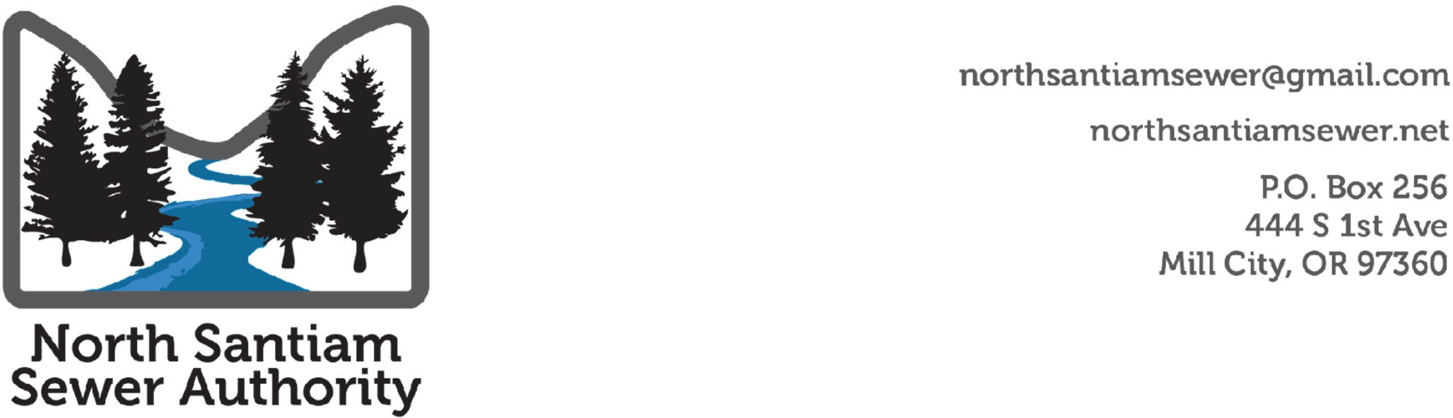

**Board Meeting**

**Summary Notes**

**September 11, at 6:00 PM**

<https://zoom.us/j/93414748822?pwd=MjJkM3Vyb21YS1BDK2doVEpIZ25uUT09>

Meeting ID: 934 1474 8822

Passcode: 454959

Called to order 6:03 p.m. Adjourn 8:00pm.

1. Roll Call and Declarations of Conflicts of Interest

**Present: Kirsch, Evans, Nielsen, Zeyen-Hall, Gander**

**Absent:** None

**Zoom: Morones, Woodward**

1. **Announcements**

None

1. **Public Comment**
2. **Action:**
3. August Summary Notes were approved. Denny Nielsen moved to accept. Tony Morones Seconded. Motion passed unanimously.
4. The county presented information about the project activities including FCS presentation on an updated rare study. Discussion occurred about the FCS study.
5. COG staff presentation. Staff explained that Local Government Law Group had advised NSSA obtain separate representation to assist with interim operating agreement and related work. LGLG is willing to continue to provide general representation to NSSA.

Motion for COG to create scope of work and process to procure an attorney firm to assist with interim operating agreements and related work to prepare to receive sewer system assets.

Motion by Brian Gander. Second by Denny Nielsen. Motion passed unanimously

**Upcoming Events:**

|  |  |  |
| --- | --- | --- |
| **Date** | **Event** | **Location** |
| September 18th, 6-8 pm | NSSA Board Work Session | Gates Fire Hall |
| October 2nd, 6-8 pm | NSSA Board Meeting | Mill City |
| October 16th, 6-8 pm | NSSA Board Work Session | Mill City |
| November 6th, 6-8 pm | NSSA Board Meeting | TBD |
| November 20th, 6-8 pm | NSSA Board Work Session | TBD |
| December 4th, 6-8 pm | NSSA Board Meeting | TBD |
|  |  |  |